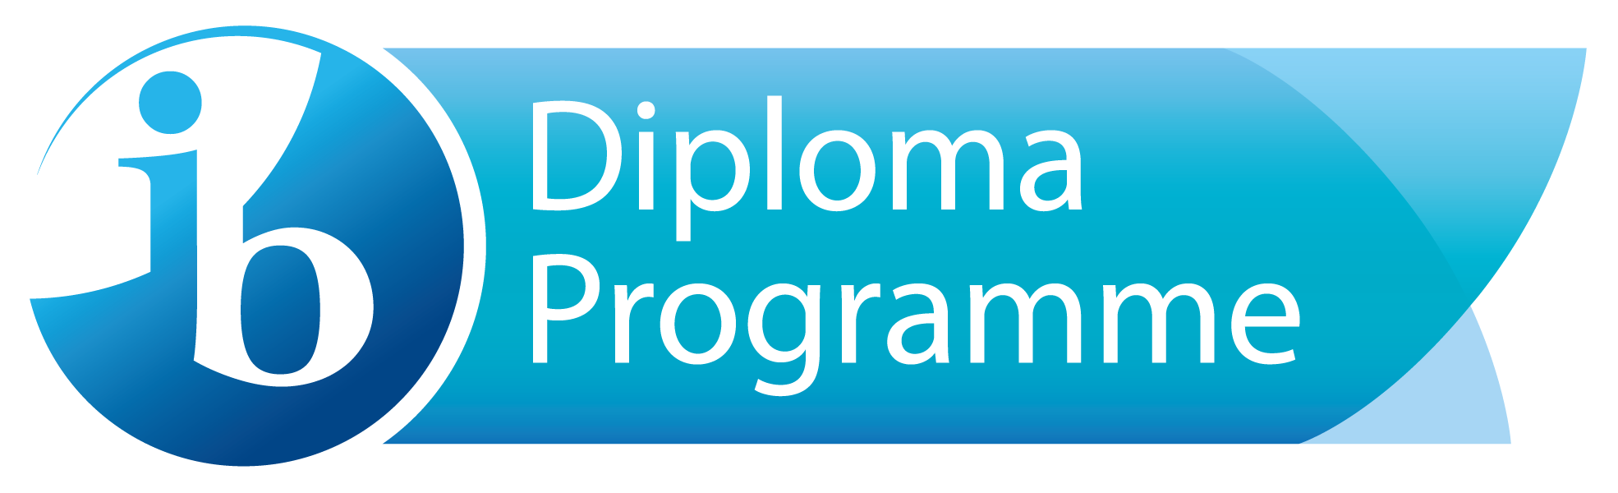

Dear IB Families:

Taking the International Baccalaureate exams is an important part of all IB courses. Troy High School desires that all students take IB exams for the IB classes that they have taken. Scoring well on an IB exam can often earn students college credit for their high school class, saving a significant amount on tuition.

For the 2021 IB exams, students at Troy High School will be registering online. This registration will take a few minutes and can be completed from any computer with internet access.

This year each IB exam costs $125.00. In addition, students will pay a one time administration fee of $20.00 for the use of the Total Registration site. Troy High School desires that every student be able to take their IB exams. Students requiring financial assistance should contact Mrs Charlotte Kirkpatrick, ckirkpatrick@fjuhsd.org, in the IB Office to learn more.

Online Exam registration will begin on Thu, Oct 1, 2020 at 6:00 AM and end on Fri, Oct 16, 2020 at 11:59 PM. In order to register, students should click on the link provided on the school website or visit [www.TotalRegistration.net/IB/051009](https://user.totalregistration.net/IB/051009) to register .To complete registration, students must answer all of the required questions. Registration is not complete until students have printed the pdf of the confirmation page that is provided at the end. We know that parents may desire to register their students for exams. We strongly recommend that parents and students are both present while registering to ensure that the correct exams are ordered.

Troy High School is excited to offer families the convenience of paying exam fees online at the time of registration. Please be sure to have a **credit card or debit card available before beginning registration**. Paying online is a great way to make sure that payment has been made while avoiding mailing payment and late fees.

Here are the important dates for the registration process:

* Thu, Oct 1, 2020 at 6:00 AM - Registration Begins
* Sun, Oct 11, 2020 at 6:00 AM - Registrations and payments after this date will incur a $20 late fee per registration.
* Fri, Oct 16, 2020 at 11:59 PM - Registration Ends
* Mon, Oct 19, 2020 - Registrations that have not been paid for will be cancelled and exams will not be ordered.
* Fri, Nov 13, 2020 - Last day to cancel an exam and receive a full refund.

Please contact Mrs Charlotte Kirkpatrick, ckirkpatrick@fjuhsd.org , if you would like to register for an exam not listed or have any questions. (Eligible courses are listed below for those students not in full IB but may be interested in testing in some of their courses this year.)

Eligible Course exams: IBSL Computer Science; IB SL Design Technology, IBSL Business, IBSL Film, IBHL Film, IBHL History of America’s, IBHL Biology.

Courses Not Eligible: IBSL English and IB SL French, Spanish or Chinese are not eligible for exams because they are the first course in a two year continuum These IB exams are actually tested out of the AP English Lit or AP French, Chinese, or Spanish courses the following year.